Teacher Sample  Activity 21  Lost in Space  Can you help this star find it's way back home? |  |  |  | Start |  |  |  |  |  |  |  |  | 


Finish

Activity 21 – Designing a Maze

1. Open a Word Document. Type your Name. Hit ENTER once.
Type Activity 27. Hit ENTER twice.

2. Decide on a “theme” for your maze. Where are you starting from? Where are you traveling to? Use a thick font and size 36 point to type a title for the maze. Center the title. Hit ENTER 7 times. (You could also use Word Art for the title).

3. Go to TABLE-INSERT-TABLE. Insert a table with 15-20 columns and 15-20 rows. Highlight the whole table and set it to size 18 point font. This will make the boxes more square.

4. Make sure the Tables Toolbar is showing. Highlight the whole table and click on the border color icon (not the down arrow). You will have many choices in front of you. Click on width 3 pt, style solid line, and All on the left hand side. Click OK. You should have a table with many solid black lined squares.

5. Use the fill color to plan a route from the beginning to the end. You will erase this when you are done, but it provides a guide along the way.

6. Now, go to your borders toolbar. In the Line Style icon at the left, click on “No Border”. Then go to the maze and click “No Border” on every line that is blocking the path of your maze.

7. You are now ready to add all the dead end routes to your maze. Continue to click on “No Border” (which basically erases the line) to allow the user to weave in and out of the maze.
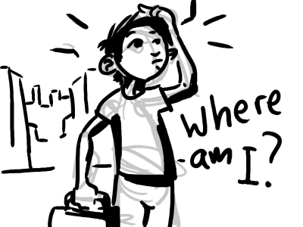
8. Go back to the fill color and change back to white the path of the maze.

9. Using text boxes and arrows, mark the start and finish of the maze.

10. Add some clip art pictures to make your maze fun and exciting!

- Save as Maze Activity 21 and submit using Google Classroom.
Teacher Sample
Activity 21


BLAST OFF!

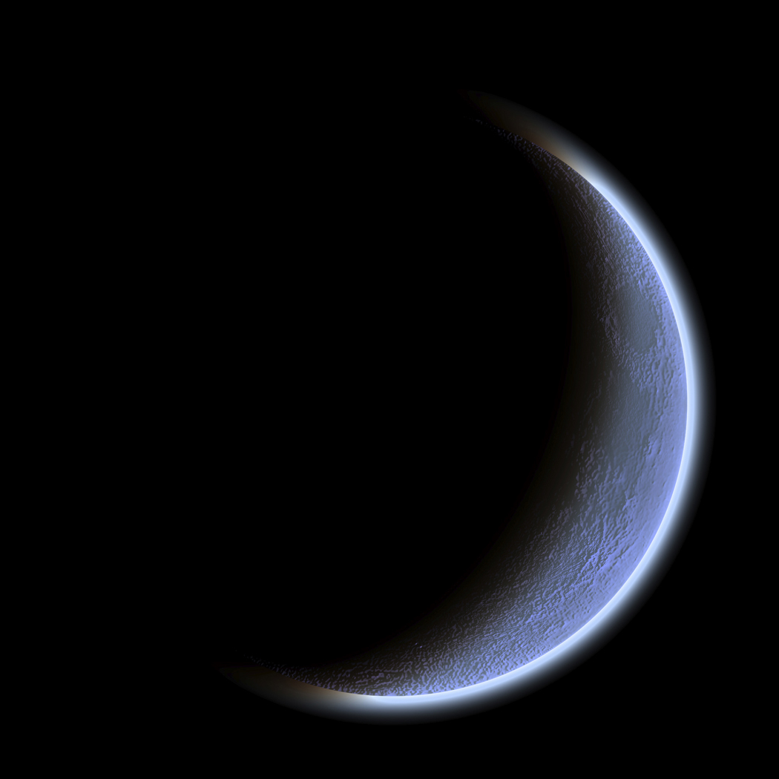

Lunar
Landing!

